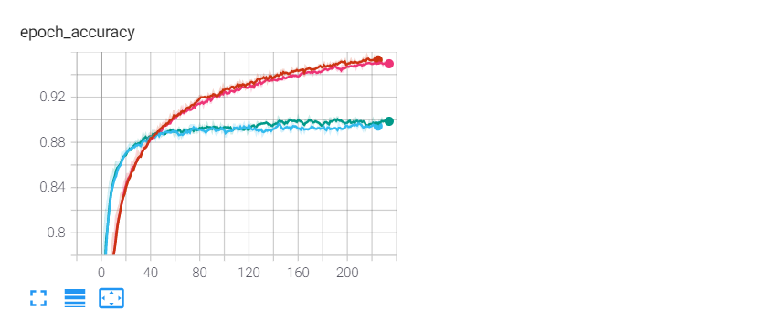

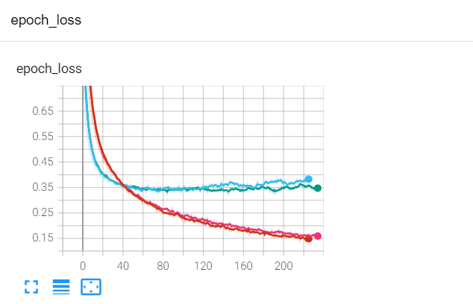

* The model: model_droput0.5.h5

Batch = 64

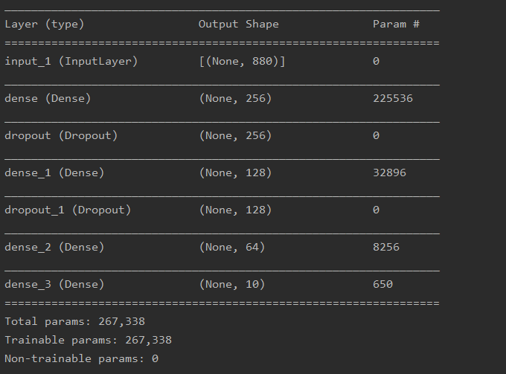

Confusion matrix

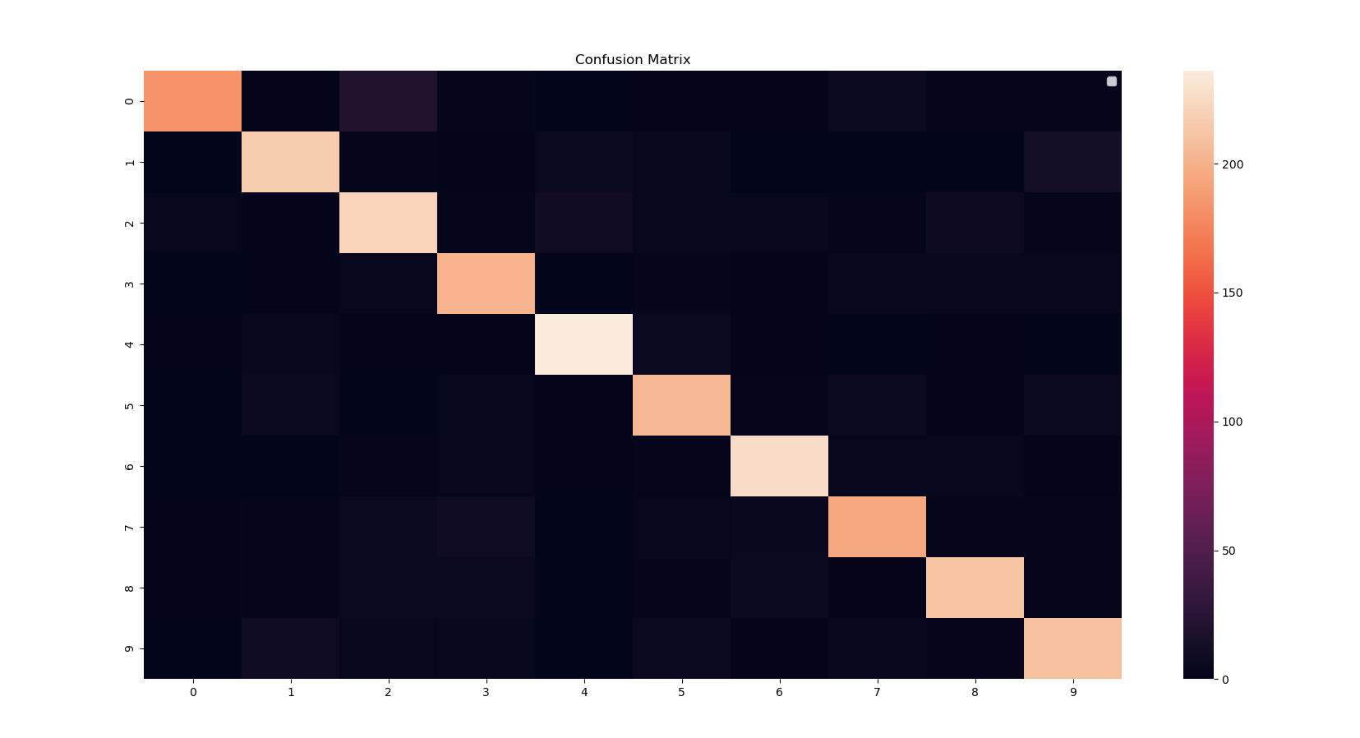

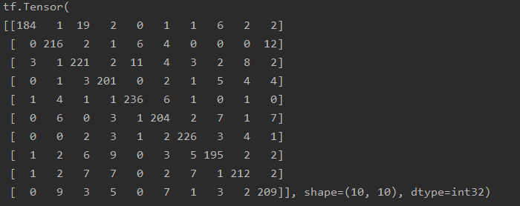



Testing with my own voice:

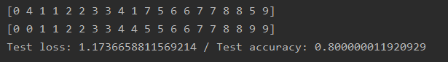

The first row is the prediction, the second one is the ground truth. For each digit there are two types of recording. The first one, corresponding to the first digit, I recorded only one digit at a time; the second digit comes from one recording where I uttered all digits from 0 to 9, then using a script split them.

Upper-bound Lipschitz constant:



20.09.2021

* **Training a constrained model: model_NoDropout.h5**

**Batch = 64**

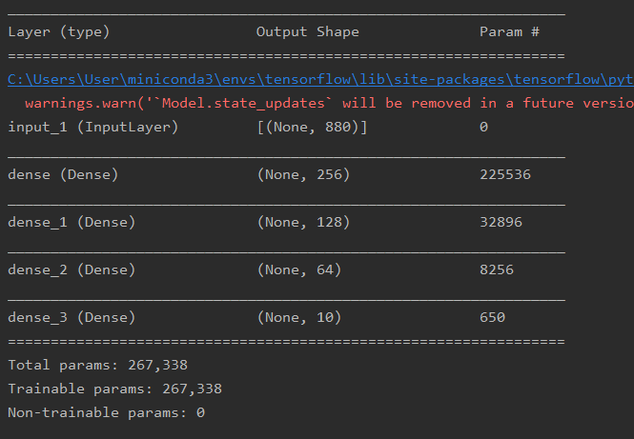

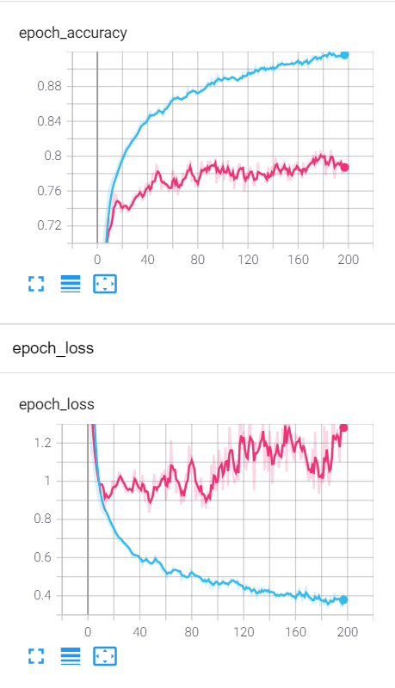

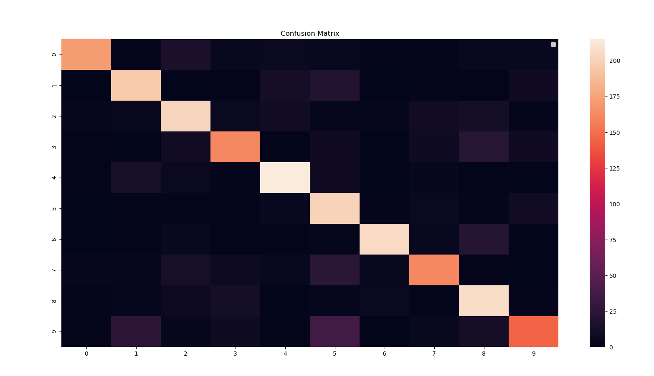

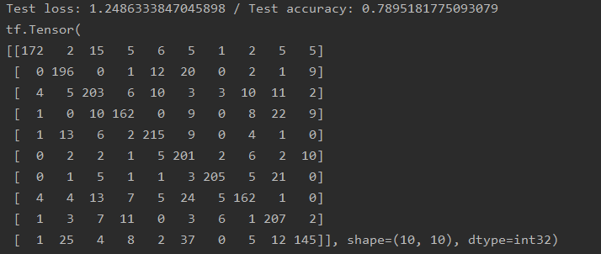

For recordings of my voice:

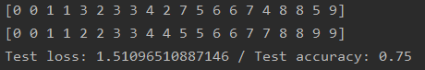

Lipchitz constant:



* **Training a constrained more complex model: model_NoDropout_moreLayers.h5**

**Batch = 256**

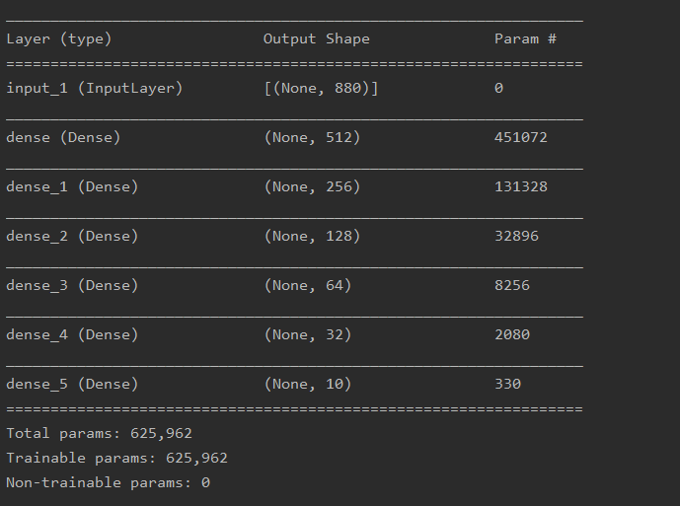

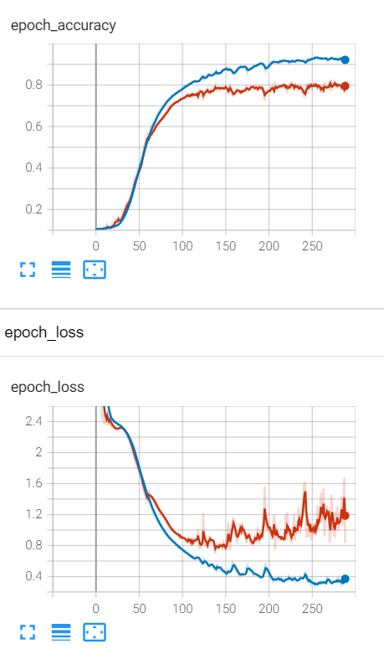

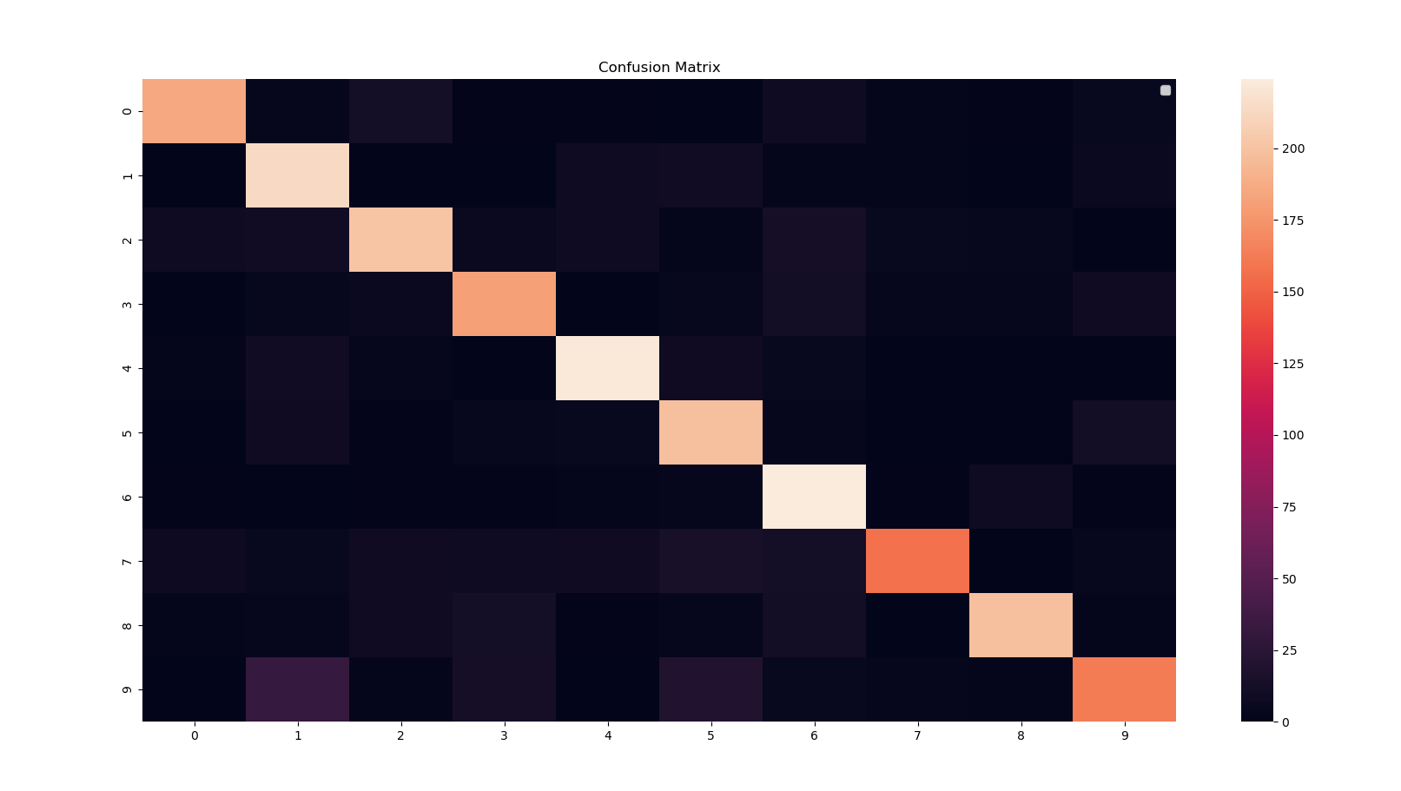

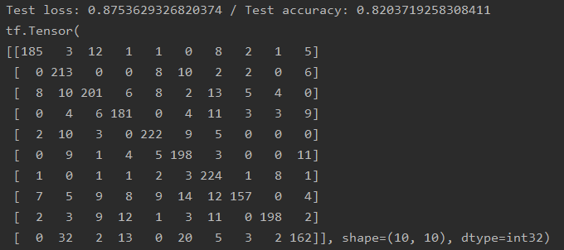

For recordings of my voice:

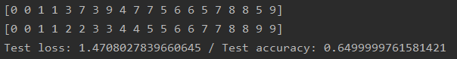

Lipchitz constant:



* **Training a constrained more complex model: model_Dropout02_moreLayers.h5**

**Batch = 64**

_________________________________________________________________

Layer (type) Output Shape Param #

=================================================================

input_1 (InputLayer) [(None, 880)] 0

_________________________________________________________________

dense (Dense) (None, 512) 451072

_________________________________________________________________

dropout (Dropout) (None, 512) 0

_________________________________________________________________

dense_1 (Dense) (None, 256) 131328

_________________________________________________________________

dense_2 (Dense) (None, 128) 32896

_________________________________________________________________

dense_3 (Dense) (None, 64) 8256

_________________________________________________________________

dense_4 (Dense) (None, 32) 2080

_________________________________________________________________

dense_5 (Dense) (None, 10) 330

=================================================================

Total params: 625,962

Trainable params: 625,962

Non-trainable params: 0

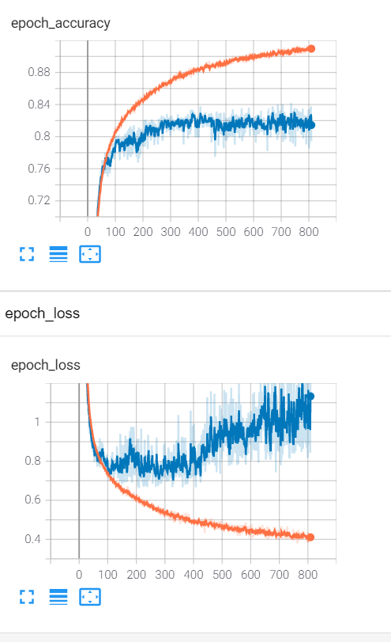

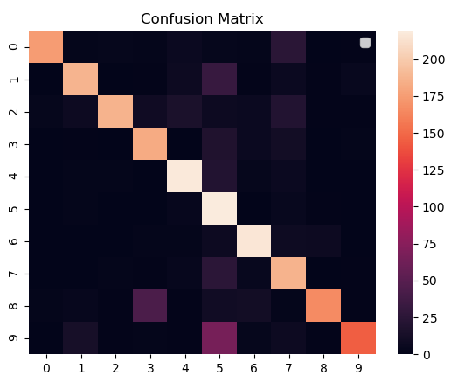

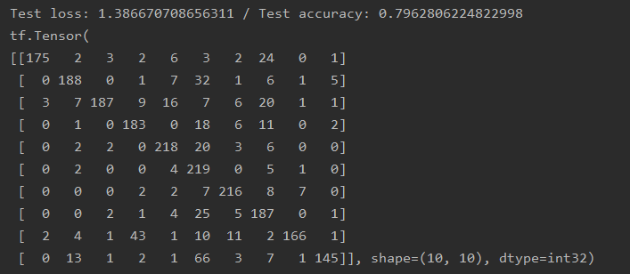

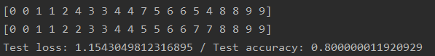



* **Training a constrained more complex model: model_Dropout02_moreLayersV2.h5**

**Batch = 64**



